in Education
Make it Happen…
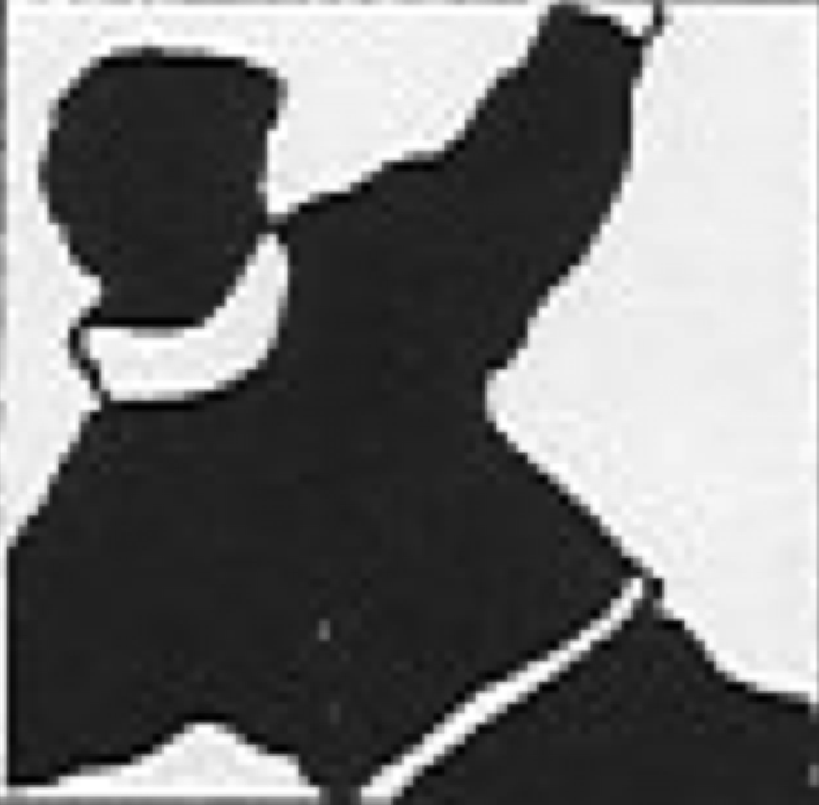 | I encourage my students to view works of art outside of school. | I build on the ideas learned from visiting artists. | I attend in-service sessions provided by arts organizations. (ie: art galleries) | My students respond critically to music. | I work with our school’s Arts Committee to plan arts curric. development activities. | I use stories, poems & music to explore real & imaginary situations with visual art. | My students regularly create visual art.
I participate in professional development to learn more about teaching drama. | I share info learned from arts organizations with students, parents & staff. | I take my students out of school to be an audience for a music performance. | I display a wide variety of student artwork throughout our school. | I pre-plan with visiting artists. | I teach so that the arts are connected to each other. | 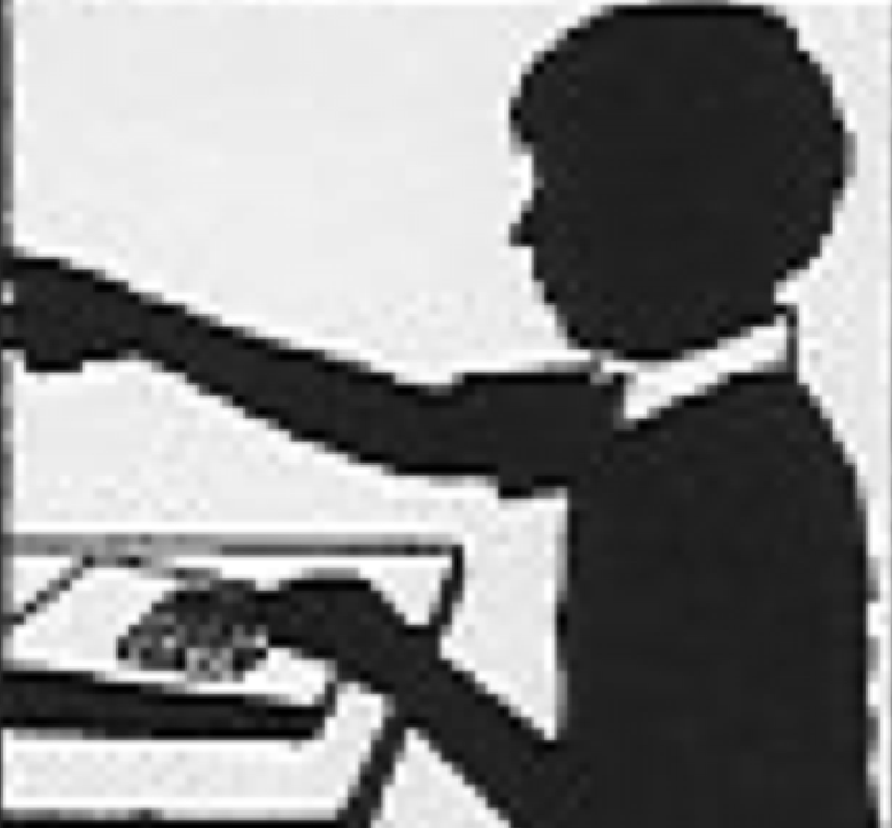 | My students use technology to enhance their work in movement.
I consciously instruct to build knowledge, creativity and critical thinking skills in arts. | My students write and speak in role. | I use recordings and audiotapes with my students. | I take my students out of school to be an audience for a drama presentation. | 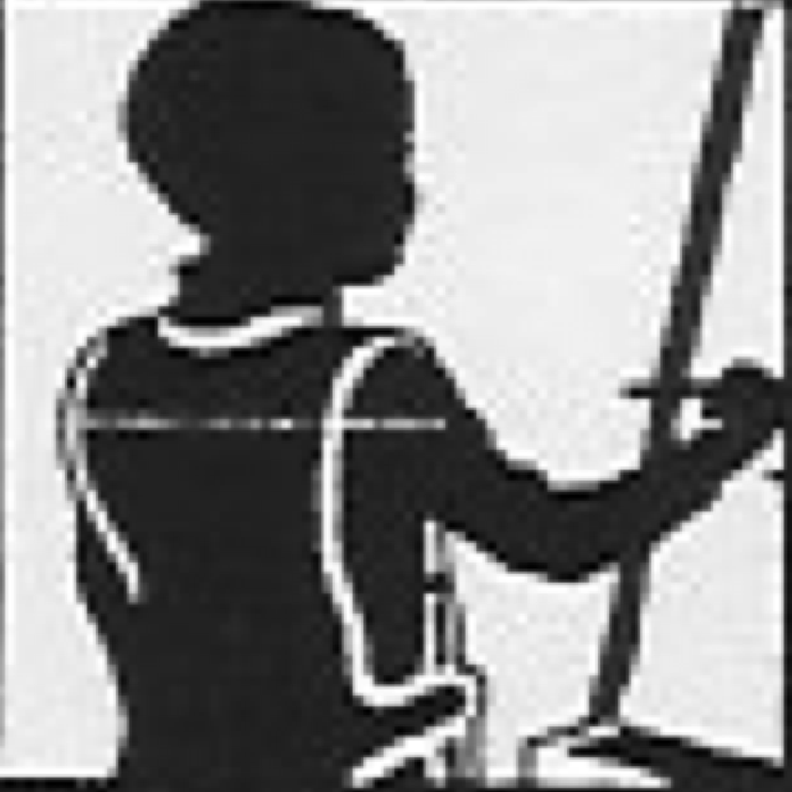 | I use stories, poems & scripts to explore real and imaginary situations with movement. | I help to create special celebrations of the arts. | My students work with a wide variety of media techniques.
The arts activities we engage in are related to the content we are studying. |  | My students respond critically to art works. | I participate in professional development to learn more about teaching visual arts. | My students use music terminology appropriately. | I join in learning with my students when a visiting artist is teaching my class. | I use technology & multi-media with my students to support learning in arts. | I recognize the effects on students of learning through the arts.
My students share their drama work with others. | My students perform music using a variety of sound sources. | I take my students out of school to be an audience for a dance performance. | I ask parents & members of the community to share their arts experiences in my classroom. | I promote arts initiatives with our community. | I ensure that the arts materials and processes I use are safe. | 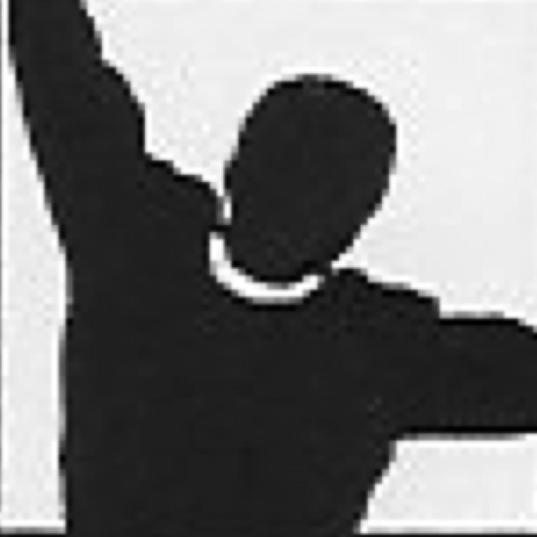 | My students use visual arts terminology appropriately.
When the artist is teaching I collect evidence about the effects on learning. | I participate in professional development to learn more about teaching dance. | My students respond critically to dramatic presentations. | 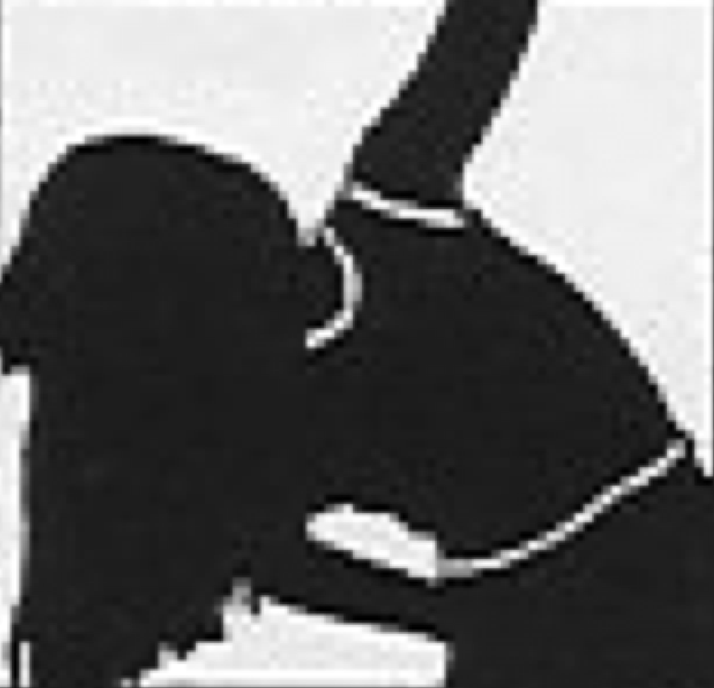 | My arts activities are planned as an on-going series of events. | I collect and use information about the Artist in the Schools program (masc). | My students’ artwork is unique and personal. | My students sing regularly.
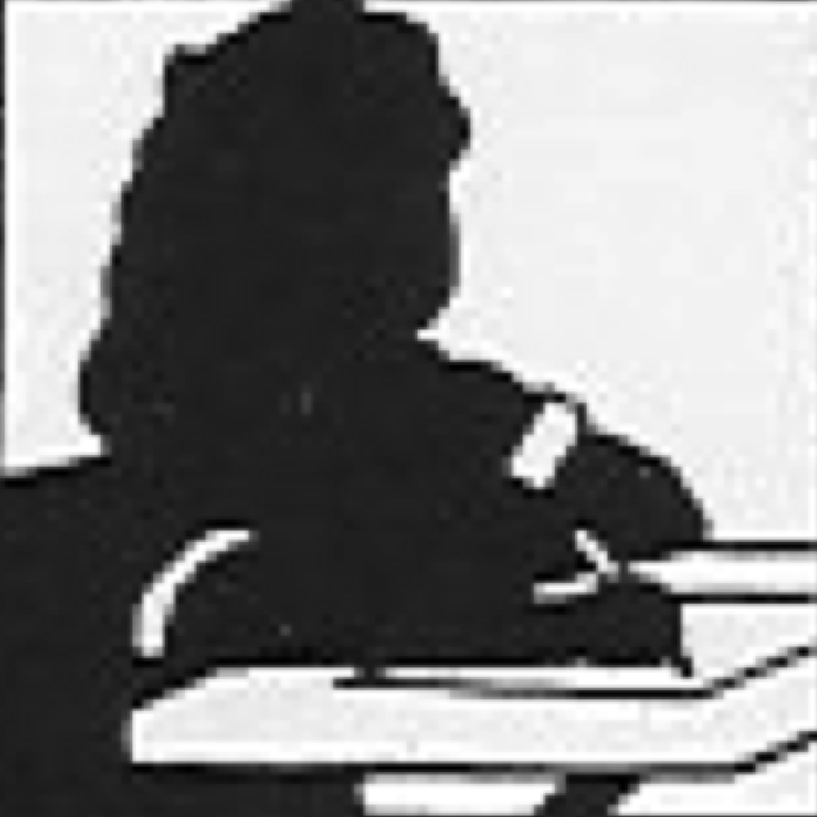 | My students use dance terminology appropriately. | I pre-plan with arts organizations to make visits more meaningful. | I am part of our school’s Arts Committee. | My students play instruments. | My students create drama pieces to communicate their ideas. | I work with parents & others to create special celebrations of the arts. | I use slides, reproductions, and media with my students to teach art appreciation.
I encourage our School Council and the wider community to support school arts initiatives. | I plan and assess arts lessons based on the Ontario Arts Curriculum. | My students attend musical performances in our school. | I know the arts allow student learning through multiple intelligences. | The arts activities I engage in are connected with other content we are learning. | I participate in professional development to learn more about teaching music. | My students draw upon a variety of sources to create drama.
Revised from grid designed by Heather Miller and Larry Swartz

