Presentation of low-organization cooperative game

Equipment required: parachute, balls (nerf); bean bags and skipping ropes (optional)

Modifications: Students who use wheelchairs can participate in both Make Waves and Popcorn by joining the circle of students around the parachute and waving their arms. If a child is unable to participate, the parachute can be tied to their wheelchair so that they may enjoy the breeze and waving bright colours. For Cat and Mouse and Shark and Lifeguards, students can stand or sit on a chair instead of the floor. Also, for students unable to participate at all, have the students sing songs will allow the students to sing/hear the songs. Another way to include students who are not able to participate fully is have them be in charge of counting to 3 (for example, when the students lift the parachute as high as they can in Mushroom).

Make Waves: While gripping the parachute, everyone moves their arms up and down to make small and large waves.  Adaptations: This game can be turned into Duck, Duck, Goose to increase level of physical activity. Or you can play Colours. In Colours, students are making waves and then the teacher (or a student) can call out one of the colours and students run under the parachute to switch spots with another student. | 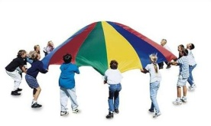
Popcorn: Place a number of beanbags (or nerf balls) on the chute. Shake the chute to make them rise like popcorn.  Adaptation: Add skipping ropes (snakes!) and try to shake them off the parachute. | 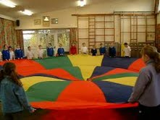
Mushroom: From a standing position, lift the parachute from the ground to waist height, counting one (lift) and two (lift). On three (lift), have everyone raise the parachute high over their heads and then crouch down, pulling the parachute tightly behind them. A mushroom effect is created as the parachute settles.  Adaptation: For younger students, have them sit outside the parachute, around the edge. Then, one or more students can crawl over parachute to flatten it. | 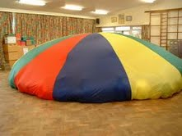
Cat and Mouse: One child (mouse) is under the chute and everyone else is shaking it quite close to the ground. Another child (cat) crawls on top and moves around trying to hunt and tag the mouse. Students should have shoes off and crawling on all fours (not upright).  Adaptation: Have 5 children be mice under the parachute. While waving the parachute, students begin counting down from 30 or a larger number if the kids are very young. When a mouse is tagged, it must stay where it is under the parachute. The cat must catch all the mice before the count is over. | 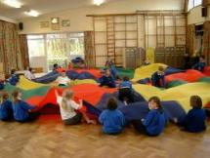
Sharks and Lifeguards: Everyone sits on the floor in a circle (shoes off) holding the parachute stretched out with legs underneath it. The chute is the sea and they are sitting on the beach, happily dipping their toes in the water. By shaking the edge of the chute realistic ripple or wave effects can be generated. Once the waves are going well someone is selected to be a shark and disappears under the chute. They move around underneath and because of the waves it will be difficult to see where they are. The shark chooses a victim and grabs him or her by the feet. The victim can give an appropriate scream before disappearing under the chute. This person now becomes a new shark.  Adaptation: To prolong the game you can have the original shark revert to being a bather - or to make it more lively you can have several sharks in there at once. To finish the game you can choose 'once a shark, always a shark' - so everyone eventually becomes a shark. You can introduce freak weather conditions - or even a killer whale! | 